**Experiment 37**

**AIM :**

To design turing machine(TM) of string format of a^nb^2n in automata.

**Design and output:**

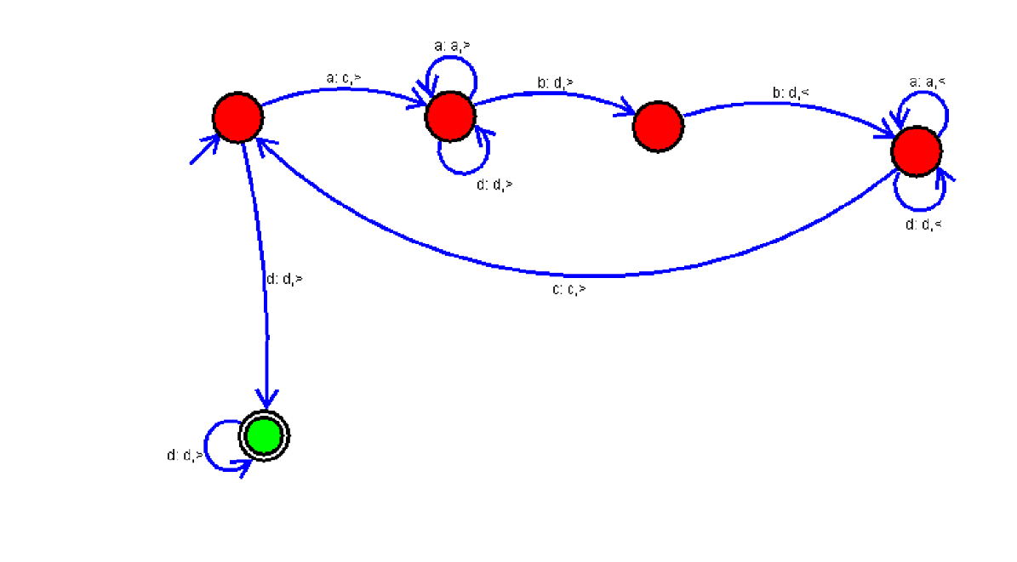

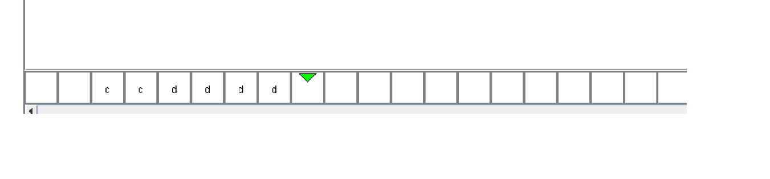

**Result:** Thus designing TM of string a^nb^2n is done and verified by giving sample inputs.